Assignment 1 Java Environment Setup

Student Information
- Name: Krishnan Madhuratnam
- Section: 2cse22
- Roll Number: 25scs1003001176

Java Development Kit (JDK)
The Java Development Kit (JDK) is a full software development environment used for developing Java applications. It includes the Java Runtime Environment (JRE), an interpreter/loader (Java), a compiler (javac), an archiver (jar), a documentation generator (javadoc), and other tools needed for Java development.

Java Runtime Environment (JRE)
The Java Runtime Environment (JRE) is a software package that provides the minimum requirements for executing a Java application. It consists of the Java Virtual Machine (JVM), core classes, and supporting files.

Java Virtual Machine (JVM)
The Java Virtual Machine (JVM) is an abstract computing machine that enables a computer to run a Java program. It converts Java bytecode into machine-specific code.

Differences Between JDK, JRE, and JVM
- JVM (Java Virtual Machine): An engine that provides a runtime environment to drive the Java code or applications. It is responsible for executing the bytecode.
- JRE (Java Runtime Environment): A bundle of software that includes the JVM, core libraries, and other components to run Java applications. It does not contain development tools like compilers.
- JDK (Java Development Kit): A comprehensive kit for developing Java applications. It includes the JRE and all necessary development tools (compiler, debugger, etc.).

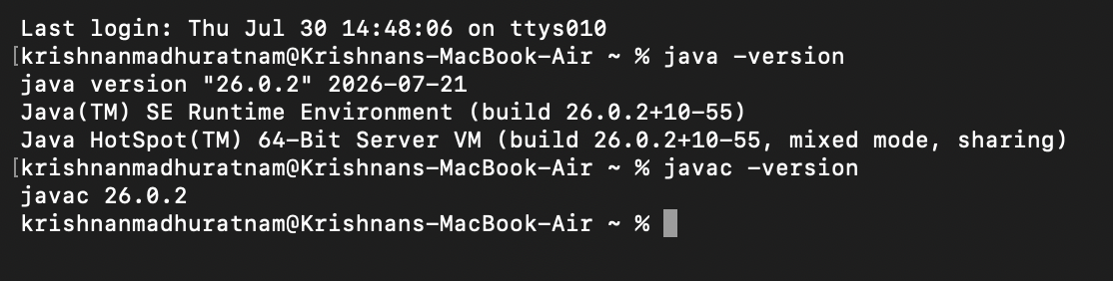

Environment installed successfully.

